What is DFD:

In Software engineering DFD(data flow diagram) can be drawn to represent the system of different levels of abstraction.It defines the overall structure of a software or website.

there are three types of DFD:

1) 0 – level – DFD Basic Diagram

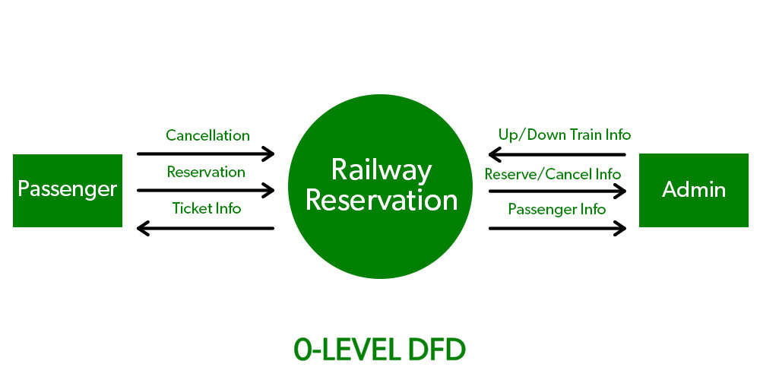

2) 1 - level DFD Intermediate diagram:-

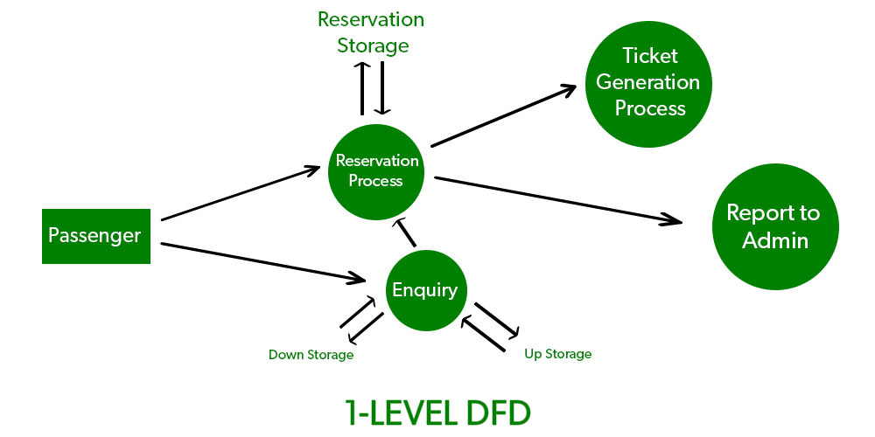

3) 2 -level DFD advance daiagram:

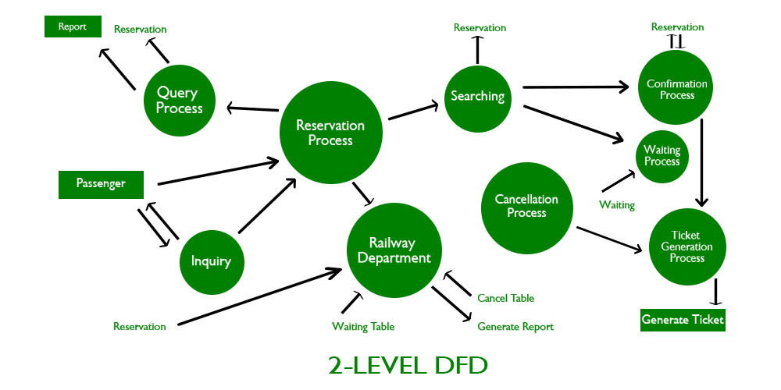

\*Create a DFD diagram on Flipkart:-

1) 0 – level – DFD:-

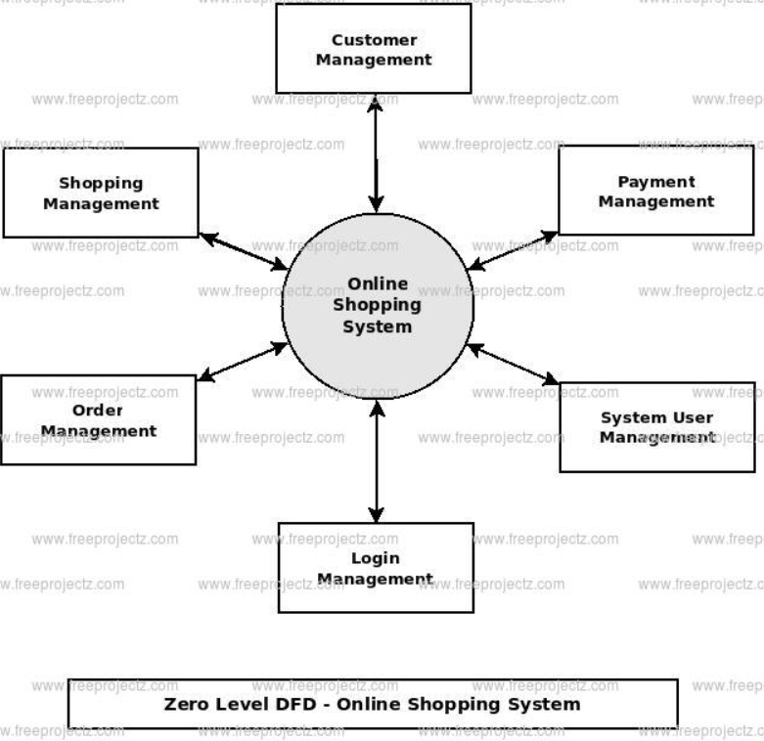

1 - level DFD:-

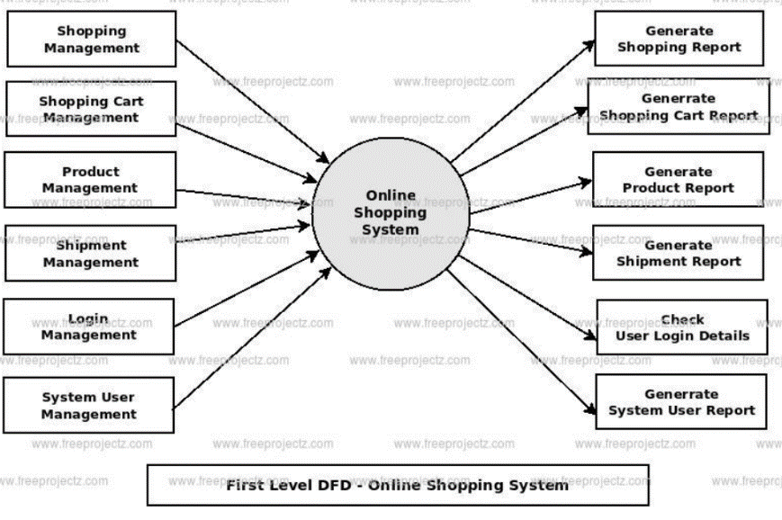

3) 2 -level DFD :-

